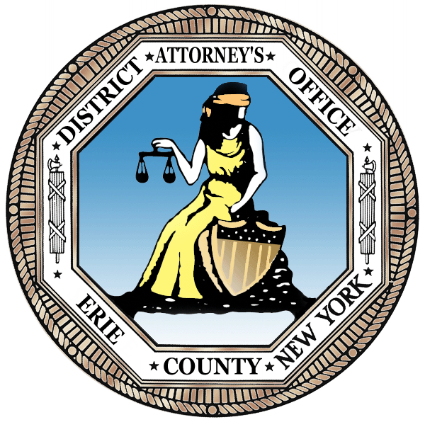
John J. Flynn, District Attorney
Erie County
District Attorney’s Office
FOR IMMEDIATE RELEASE

June 26, 2017

BUFFALO MAN GETS JAIL SENTENCE FOR TRAINING PIT BULLS TO FIGHT

Erie County District Attorney John J. Flynn announces that 49-year-old Shondel Stephens of 61 Monroe Street in Buffalo has been sentenced by State Supreme Court Justice Russell P. Buscaglia to six months in jail and five years probation for dogfighting.

Justice Buscaglia also prohibited Stephens from owning any animals while on probation.

In April, Stephens pleaded guilty to Prohibition of Animal Fighting.

Stephens was using his residence as a facility to train pit bulls for dogfighting. On or about August 31, 2016, SPCA agents entered the defendant’s home on a search warrant. The agents located two severely injured pit bull dogs and animal fighting paraphernalia used to train dogs for the blood sport of dogfighting.

“We have zero tolerance for these cases,” says DA Flynn. “Our office is aggressively prosecuting animal abusers and will fight to put them in jail.”

DA Flynn commends SPCA Agents Christina Vitello and Richard Rosenberry and Veterinarian Dr. Helene Chevalier for their thorough investigation.

Assistant District Attorney Justin T. Wallens of the DA’s Animal Cruelty Unit prosecuted the case.

